Dynamic Connectivity

We will look at 2 classic algorithms here, quick find and quick union. This doesn’t find actually the path between the two objects; it just answers if there is a path or not.

* Given a Set of N objects:
  + **Union Command**: Connect 2 object.
  + **Find/connected query**: is there a path connecting two objects.

**Example:**

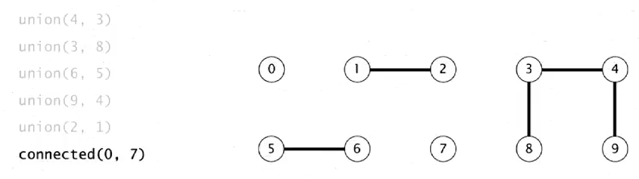

It will return false as 0 and 7 isn’t connected.

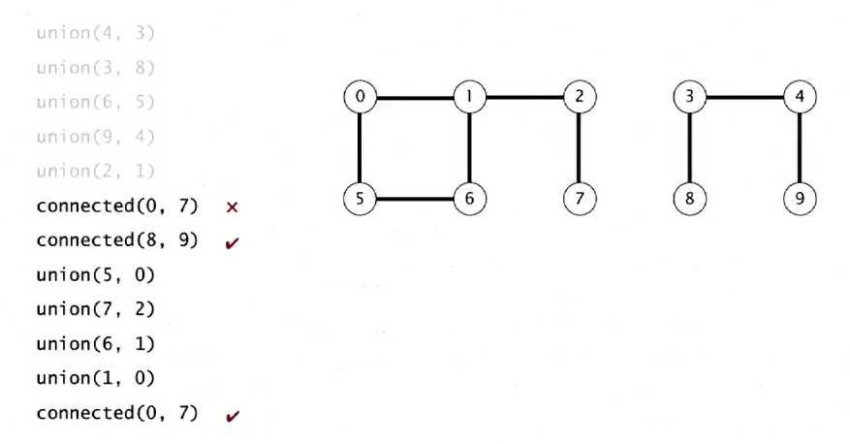

But in this case, it will return true, since both are connected

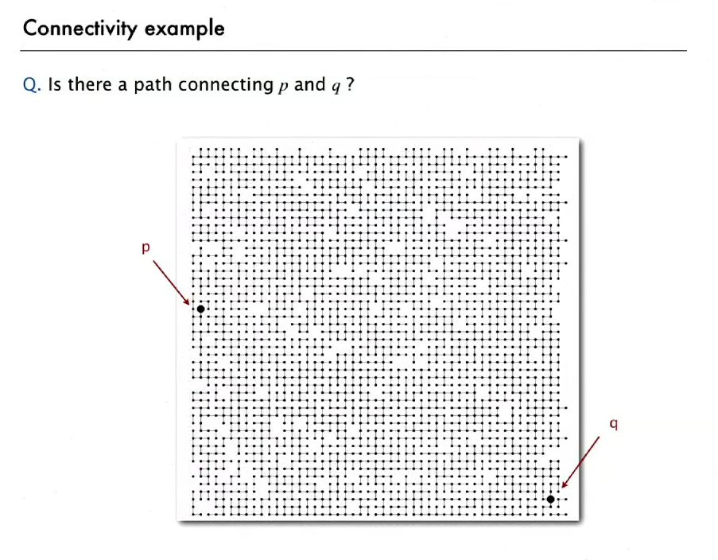

Practical Example

* **Connected Components:** Maximal set of objects that are mutually connected.

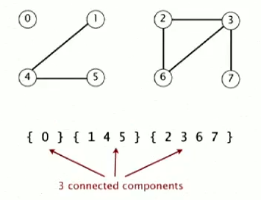

* **Implementing the operations**

